# Lab: CSS Selectors and Rules

Problems for exercises and homework for the ["HTML and CSS" course @ SoftUni](https://softuni.bg/courses/web-fundamentals-html5). Submit your solutions in the SoftUni judge system at <https://judge.softuni.bg/Contests/795/Lab-Introduction-To-CSS>.

## Photo Shoot Effect

Create a Web Page like the following using "**photo-shoot-effect.html**"

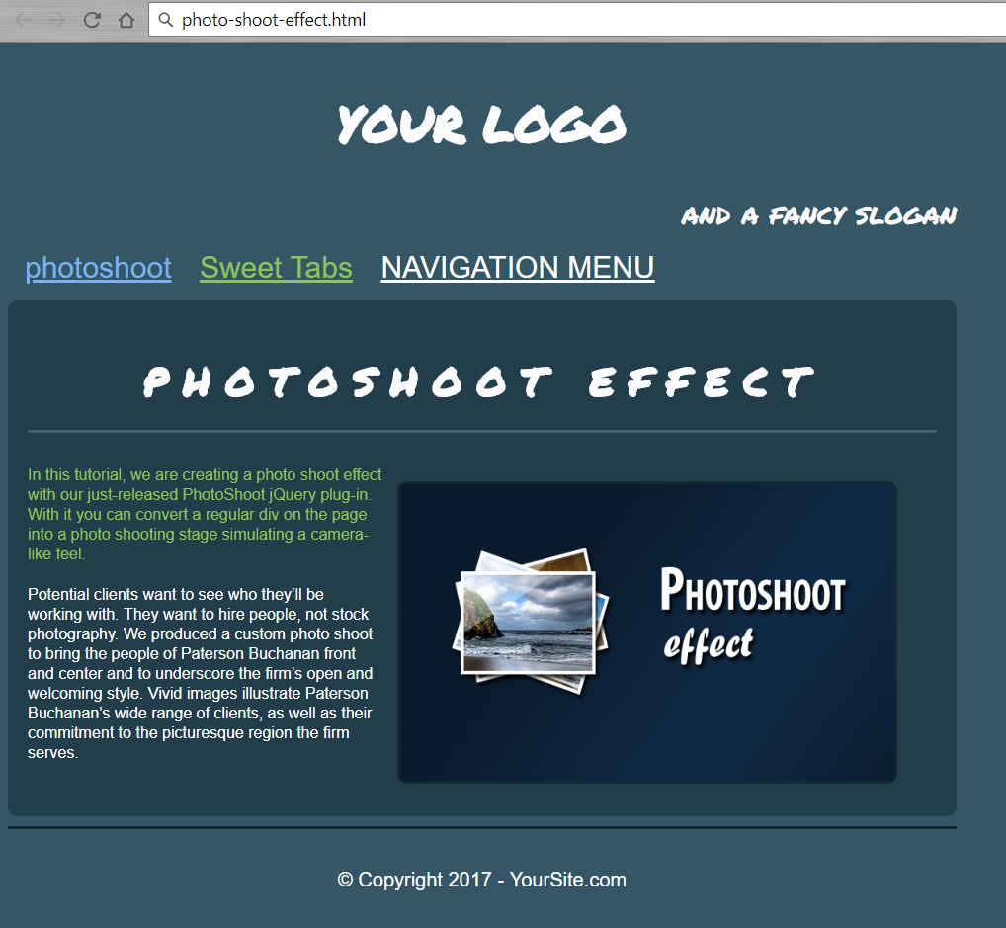

Create file: "**photo-shoot-effect.css**"

You are **NOT** allowed to change the HTML file.

### Constrains

* **Body**
  + Width: **960px;**
  + Center the body
  + Font family: **Arial, sans-serif;**
  + Text color: **#fcfcfc;**
  + Background color: **#355664;**
* **Headings**
  + Font family: **Permanent Marker, Arial, sans-serif;**
* <h1>
  + Text size: **50px;**
  + Padding: **10px 0 0;**
  + Center the text
* <h2>
  + Text size: **40px;**
  + Letter spacing: **15px;**
  + Center the text
  + Border at the bottom: **3px solid #416371;**
  + Padding at the bottom: **20px;**
* <h3>
  + Text Align: **right;**
  + Text size: **30px;**
  + Font-weight: **normal;**
  + Margin: **0 0 10px;**
* **Paragraphs**
  + Line height: **20px;**
  + Padding bottom: **5px;**
  + Text Color: **#94c258;**
* **Images**
  + Width: **500px;**
  + Height: **300px;**
  + Border: **None;**
* **Div** with class = "**article-content**"
  + Margin: **15px 0;**
* **Navigation**
  + Background: **#355664;**
  + Padding-right and Left: **5px;**
  + Padding-top and Bottom: **0px;**
* **Hyperlinks**
  + Text Color: **#ffffff;**
  + Text Color: **#7CB3E9;**
  + Text Color: **#8EC45B;**
  + Margin: **5px 2px;**
  + Padding: **7px 10px 4px;**
  + Text Size: **30px;**
* **Article**
  + Height: **390px;**
  + Background: **#213E4A;**
  + Padding: **20px;**
  + Margin: **0 0 10px;**
* **Figure**
  + Border: **3px solid #142830;**
  + Float: **right;**
  + Height: **300px;**
  + Width: **500px;**
  + Marginleft: **15px;**
* **Footer**
  + Border at top: **3px solid #142830;**
  + PaddingTop: **15px;**
  + MarginBottom: **30px;**
  + Centerthetext
  + Textsize: **20px;**

### Hints

Use:

* Reset the CSS file;
* text-transform: **uppercase;**
* text-transform: **none;**
* text-transform: **lowercase;**
* border-radius: **10px;**

## Ancient Architecture

Create a Web Page like the following using"**ancient-architecture.html**".

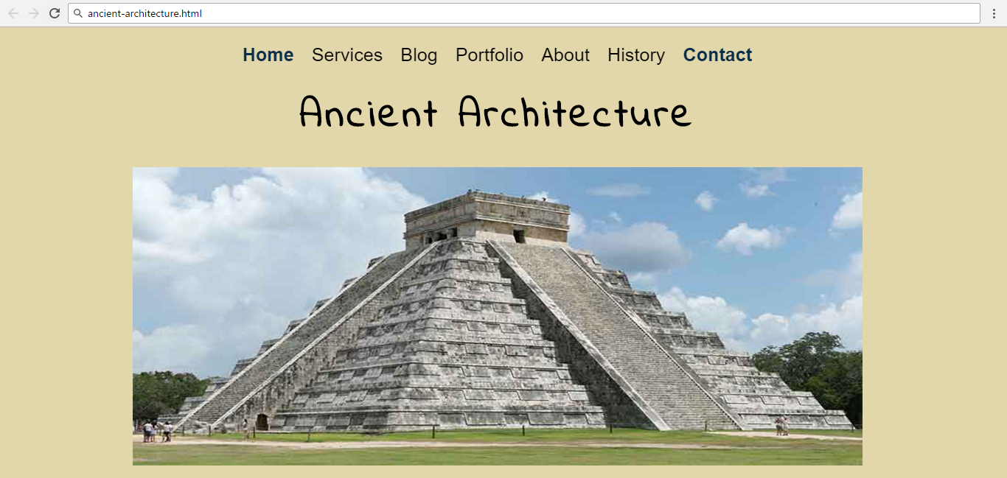

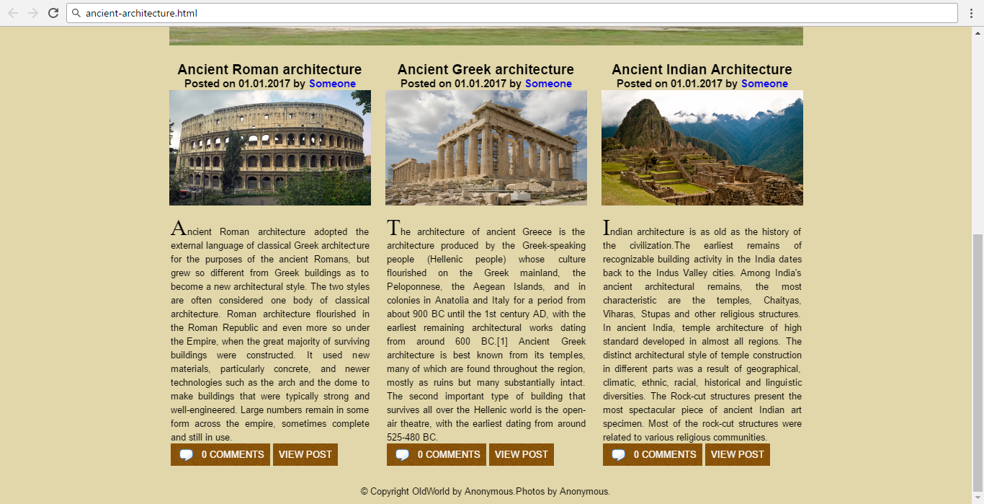

Create file: "**ancient-architecture.css**"

You are **NOT** allowed to change the HTML file.

Font Family: **Roboto, sans-serif; 'Indie Flower', cursive; EucrosiaUPC sans-serif;**

### Constrains

* **Body**
  + Font Family: **Roboto, sans-serif;**
  + Background color:#e2d7aa;
  + Text Color:#000000
  + Text size: 16px
  + Width:1180px;
  + Center the **container**
* **Image**
  + Width: **1100px;**
  + Height: **450px;**
* **Image - container**
  + Width: **1600px;**
  + Height: **450px;**
  + Margin at Top: **65px;**
* **<h1>**
  + Text size: **60px;**
  + Center the text
  + Margin at the top: **65px;**
  + Font Family: **‘Indie Flower’, cursive;**
* **Navigation**
  + Margin: **30px;**
* **Hyperlinks**
  + Text size: **28px;**
  + Text-color: **#000000;**
* **Hyperlink**
  + Text-color:#0a2d4a;
  + Font Weight: **Bold;**
* **Image** inArticle
  + Width:350px;
  + Height: **200px;**
  + Margin Bottom:20px;
* **First Letter in paragraph**
  + font-family: **EucrosiaUPC, sans-serif;**
  + Text size: 40px;
* **Hyperlink in span**
  + Background: **url(images/bg2.jpg)**
  + Textcolor:#ffffff;
  + Padding: 10px;
  + Margin-top: 10px;
* **Footer**
  + Margin: 0px;
  + Padding: 10px 0 10px 0;
  + Center the text

### Hints

To style the comments box use:

**article p:last-of-type span:first-of-type a::before** {

content: url("images/comment.png");

position: relative;

right: 5px;

top: 7px;

padding: 10px;

}